E COMMERCE DASHBOARD

High Level Design (HLD)

ABHISHEK CHAVAN

# Document Version Control

|  |  |  |  |
| --- | --- | --- | --- |
| **Date Issued** | **Version** | **Description** | **Author** |
| **14th June 2023** | 1.0 | First Version of Complete HLD | Abhishek Chavan |

ABSTRACT

E-commerce, often known as electronic commerce, is the

exchange of goods and services as well as the sending of money

and data through an electronic network, most commonly the

internet. These Business-to-Business (B2B), Business-to-

Consumer (B2C), Consumer-to-Consumer (C2C), or Consumer-

to-Business (C2B) transactions are all possible.

E-commerce analytics is the practise of compiling information

from every source that affects the store. Then, this information is

used to understand changes in consumer behaviour and emerging

online retail trends. Insights from the data will allow to make better

informed choices, which should lead to an increase in online sales.

A comprehensive range of KPIs related to the entire customer

journey, including discovery, acquisition, conversion, retention,

and advocacy, can be included in e-commerce analytics.

Examining the sales results for each of the products under a certain

category helps to understand the top-selling products.

Dashboards help the company to analyse the sales and profit trends

and give an insight regarding which areas need to be focussed in

order to boost the profits

CONTENTS

Document Version Control……………………………………...2

Abstract………………………………………………………….3

1. Introduction…………………………………………….5-6

1.1 Why this High-Level Design Document?.....................5

1.2 Scope………………………………………………….6

2. General Description………………………………….…...6

2.1 Problem Statement……………………….…………...6

2.2 Tool Used……………………….………..…………...6

2.3 Excel Features Used………………………..................6

3. Design Details…………………………………………..7-9

3.1 Functional Architecture…………………………….7-8

3.2 Optimization………………………………………..8-9

4. KPIs………………………………………………………9

4.1KPIs (Key Performance Indicators)…………………...9

5. Deployment……………………………………………...10

# Introduction

## Why this High-Level Design Document?

The purpose of this High-Level Design (HLD) Document is to add the necessary detail to the current project description to represent a suitable model for coding. This document is also intended to help detect contradictions prior to coding, and can be used as a reference manual for how the modules interact at a high level.

The HLD will:

* Present all of the design aspects and define them in detail
* Describe the user interface being implemented
* Describe the hardware and software interfaces
* Describe the performance requirements
* Include design features and the architecture of the project • List and describe the non-functional attributes like:

o Security o Reliability o Maintainability o Portability o Reusability o Application compatibility o Resource utilization o Serviceability

## Scope

The HLD documentation outlines the system's architecture,

including the technology architecture, application architecture

(layers), application flow, and database architecture. The HLD

employs simple to somewhat complex concepts that system

administrators should be able to understand

# General Description

## Problem Statement

An online e-commerce company's analytics team wants to create

a sales dashboard to evaluate sales based on different product

categories. The business aims to provide people more choice over

product categories so they may choose one and can observe the

trend month- and product-wise as appropriate

## Tools used

Microsoft Excel is use to design he dashboard to gain insights

about the sales and profits trends of the company.

# Design Details

## Functional Architecture

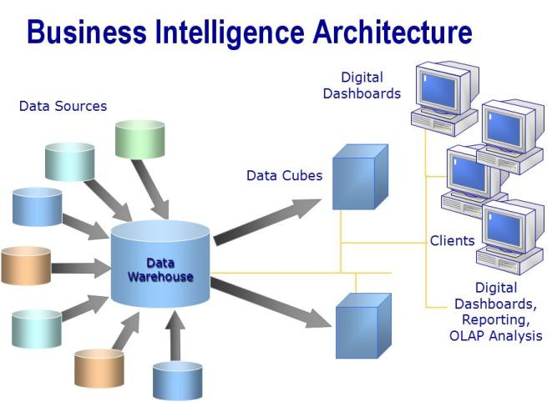

Figure 1: Functional Architecture of Business Intelligence

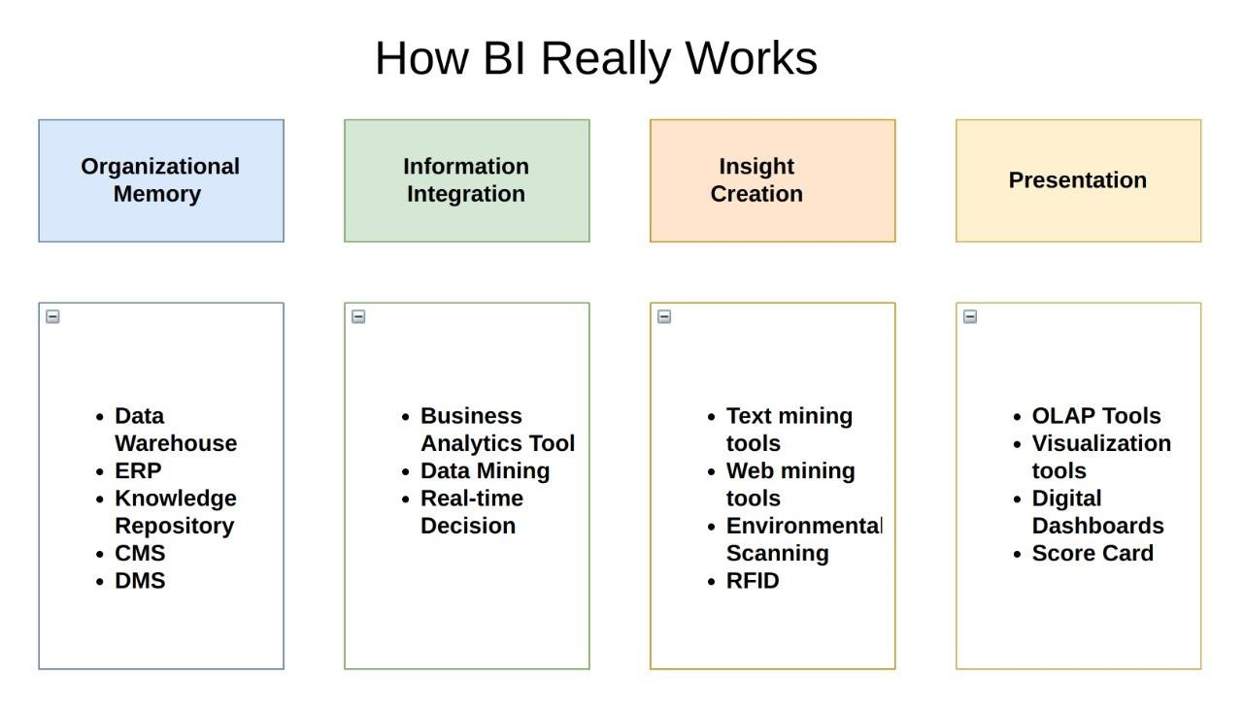

## Optimization

Goal-seeking analysis for one or more variables under certain

restrictions include optimization analysis, which is a more

complicated component. Even there is power to modify the

restrictions and manage the optimization procedure, it could sound

quite difficult. However, Solver was launched by Microsoft Excel

to make such optimization analysis simpler.

The What-if analysis tool known as Excel Solver has a unique

collection of commands. In many commercial and engineering

models, it serves as a simulation and an optimization tool.

The finest tool for optimization with constraints is Excel Solver. It

aids in calculating the return on investments, ideal budget,

production costs, labours scheduling, and many other things.

# KPIs

Dashboard will be used to display and highlight KPI and

important factors affecting the sales and profits. Dashboards will

be incorporated as soon as the system begins collecting historical

or regular data for a user in order to show progress on various

indicators or factors over time.

## KPIs (Key Performance Indicators)

In the dashboard, the following indicators have been used

1. Sales
2. Quantity
3. Profit

# Deployment

Whatever strategy is chosen to grow the e-commerce business,

there are certain activities and actions that must be performed. The

e-commerce business can be boosted by taking important steps

like accounting, sales tracking, scheduling, marketing, and

reaching a larger target audience and these may be completed

by designing dashboard corresponding to the business data

in Microsoft Excel which can help generate useful insights for the

business.

.